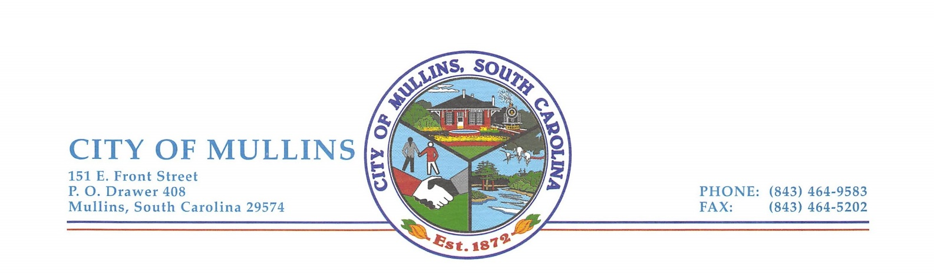

Museum Committee Meeting
Mullins City Hall * Conference Room
Thursday, July 6, 2023
2:00 P.M.

A G E N D A

1. Call Meeting to Order & Welcome: Chairperson Phillips

Pledge of Allegiance:
Invocation:
Civility Pledge:

2. Disclosure that local media has been informed of meeting pursuant to South Carolina Freedom of Information Act:

3. Approval of Agenda:

4. New Business:

- Committee Review and Update

5. Comments:

6. Adjournment:

