Code Compliance
Homeowner’s Guide

The concept of Code Compliance is relatively new. In the mid-21st century the State of South Carolina began the process of establishing acts and laws that would govern codes, ordinances and enforcement. The goal was to place the enforcement of local ordinances in the hands of municipalities such as the City of Mullins.
The city’s philosophy is to achieve voluntary compliance with reported and discovered code violations. Education is the key to reaching this goal. One of the greatest obstacles to gaining compliance is that many citizens do not realize that they are violating local ordinances. For instance, it is not at all unusual for a resident to be unlawfully parking a vehicle on the city right-of-way without a valid tag, or parking an inoperable vehicle on your private property, violates City codes. Most people are willing to play by the rules if they know the rules.
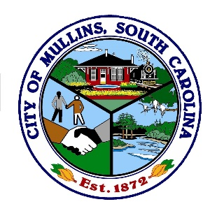
Property maintenance laws are designed to promote neighborhood integrity, prevent property value decline, reduce visual clutter and blight, and preserves quality of life. The purpose of this guide is to educate the citizens of the City of Mullins about the Code Compliance process. It is intended only as a general summary of Code regulations and is not intended as a substitute for the City of Mullins Ordinance.

City of Mullins
South Carolina
Neighborhoods and structures in the City of Mullins require proper maintenance to stay in good condition as they age. Maintaining good neighborhoods is the cooperation of individual property owners and tenants. The City of Mullins Council has adopted a code of ordinances, which create minimum standards for the improvement of our neighborhoods. These standards protect surrounding property owners and tenants from having property value negatively affected by substandard conditions
Example of a well maintained single family home.
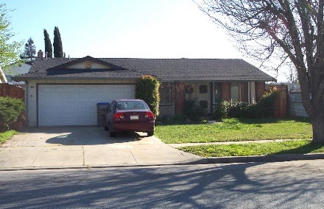

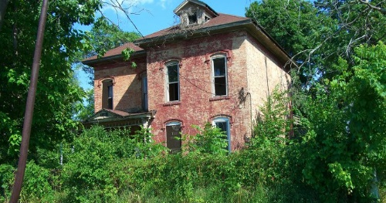
Example of a poorly maintained home with several violations.

The following are some maintenance recommendations which you can utilize to keep your property in a safe and sanitary condition.

PROPERTY MAINTENANCE
- Keep your building substantially free of dirt, stains, rust, mold and mildew.
- Ensure surfaces are free of broken glass and loose shingles.
- Maintain brick, stone, stucco, concrete and painting surfaces so as to not reflected inadequate maintenance or deterioration.

YARD MAINTENANCE
- Mow the lawn so that grass, weeds or other vegetation is 12 inches or less in height.
- Mow the edge and right-of-way on roadways or streets
- Trees that hang over the sidewalk must be trimmed.

OUTDOOR STORAGE
- No outdoor storage of goods and material or refuse containers shall be located in any yard which is visible from the public right-of-way or adjacent properties or abutting a street, nor in any required buffer or street, except for the temporary placement of refuse for scheduled curbside collection.
- Parking, storing or keeping an unlicensed or inoperative vehicle outside of a completely enclosed garage or storage facility is prohibited.

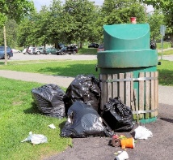
SOLID WASTE AND RECYCLABLE CONTAINERS
Solid Waste and Recyclable containers shall be placed at the street curb not earlier than 24-hours prior to the scheduled collection. To assure collection, items should be placed at the curb prior to 6:00AM the day of collection.

JUNK, TRASH, RUBBISH, AND ABANDONED ITEMS
Discarded items that are allowed to accumulate that are valueless, or have only nominal or salvage value and are abandoned or left unprotected from the elements on public property are prohibited. Yard waste must be prepared properly for pick up. Sanitation will not pick up any yard waste on undeveloped property, construction site or demolition debris. Refer to Public Works Department/Sanitation Division information on the website at https://www.mullinssc.us/public-works

WHITE GOODS are washing machine, refrigerators, stoves, dryers, water heaters and similar appliances. The City handles the collections of these items withy special collections and appointments are scheduled by calling the Sanitation Department at 843-464-9583

PERMITTED SIGNS
Only 1 real estate sign not to exceed 30 inches in height and 48 square inches is allowed on a single parcel. Only 1 open house sign shall be placed on the property no earlier than 11:30AM and shall be removed no later than 5:30PM on the day of the open house, permitted on weekends & holidays. Political signs attracting attention to political candidates or issues are permitted without a permit. Such signs, shall be located on private property with permission of the owner, shall not be located in the public right-of-way, public water ditches or other public property, or on any utility pole or tree: shall be limited to not more than 1 per candidate or issue on any single parcel, shall not exceed 32 square feet in area per side and 6 feet in height, and when referring to an election may be placed 45 days prior to the elections and shall be removed within 5 days after the election or special event.

ADDRESS NUMBERS shall contrast with the background. Numbers shall be no less than 3 inches in height for residential buildings & structures and 6 inches in height for all other buildings or structures. Must be permanently attached with a fastener (Not glue, adhesive, tape, etc.) and be numerical (no script writing or roman numbers)

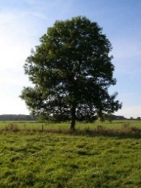
TREE REMOVAL No person shall cut down, destroy, damage, remove, or poison any native or approved non-native tree 12 inches or larger in Diameter at Base Height (DBH) within the city without an approved no-charge tree removal permit. A tree removal permit may be approved if one or more of the following circumstances exist and is evidenced by a report from an arborist: the tree constitutes a hazard to life or property which cannot be mitigated without removal; the tree is dying or dead so that its restoration to a sound condition is not practical; or it has a disease which can be transmitted to other trees. Tree replacement shall be required pursuant to Section 4.3. - Tree protection.

GARAGE AND YARD SALES
Only personal property may be offered for sale. The maximum number of “No-charge Permits” which may be issued to any person or location per calendar year is 2 and are limited to 4 consecutive days. Only one sign shall be permitted on the lot where the yard site is located. Such sign shall not exceed 2 square feet per side and 30 inches in height and shall remain in place only from 5:00PM on the day before until 8:00 AM on the day after the sale. No off-premise direction signs are permitted.

CODE ENFORCEMENT/COMPLIANT RESPONSE
In many instances, Code Compliance investigates a code violation and takes compliance action when a citizen reports a potential violation. On weekends where the code Compliance Department is closed, you may call the City of Mullins at 843-464-5660 to record a complaint.
If you would like to be notified of action “taken” on your complaint, you will need to provide a phone number or email address so you can be contacted in regards to the status of the investigation. You may also remain anonymous if you wish when making a complaint by phone or in person. All emails sent and received regarding City Business are public records and may be released as required by law.
When reporting a possible violation, you should provide Code Compliance with the exact address of the building unit number, number if applicable or as specific a location as possible to enable the inspector to locate the site. Describe the conditions you observed.
After receiving a citizen’s request, Code Compliance will inspect the property as soon as possible, to determine if a code violation exist. Public health and safety related complaints are the highest priority. If a violation is found, a courtesy notice will be either mailed to the property owner or they may receive a door hanger courtesy notice requiring compliance by a certain date.
IF YOU receive a notice of violation from the code compliance department carefully read the notice to find out what the violation is so that you can address the issue. If you have question about the violation or need additional time please call Code Compliance at 843-464-5660.

C
Code Compliance Officer inspects property based on a complaint and/or direct observation
NO
Violation Observed
(If applicable the complainant is notified
Complaint Closed

Violation(s) Found
YES
Attempt is made to verbally contact property owner and issue a Courtesy Notice via hand delivery, notice left on premises, or USPS mail.

“REASONABLE TIME” is given to correct violation(s) and re-inspection is performed.

Certified Mail received?
YES
(If applicable the complainant is notified)
Complaint Closed

Complaint Clos4ed

NO
Notice of Violation Posted on Property
No
Notice of Violation(s) issued to the property owner via Certified Mail
Violation(s) Corrected

YES
(If applicable the complaint is notified)
Complaint Closed

Violation(s) Corrected
NO
After 10 days the fine is recorded as a lien against the property
“REASONABLE TIME” is given to correct violation(s) and re-inspection is performed.

NO
Affidavit of Violation(s) and Notice of Hearing
Issued to the property owner via Certified Mail
YES
(If applicable the complainant is notified)
Complaint Clos4ed

Violation(s) Corrected

Code Enforcement issues Cease and Desist Order & Order for Corrective Actions requiring the Violation(s) be eliminated and require payment of court cost incurred. (Failure to comply may result in fines not to exceed $250 per day the violation remains + court cost)
Penalty Hearing
Code Enforcement Board assessed a fine not to exceed $250 ($500 repeat violations) per day the violation remains + court cost

NO
Affidavit of Non-Compliance and Notice of Penalty Hearing issued to the property owner via Certified Mail
Issued to the property owner via Certified Mail
Violation(s) Corrected
“REASONABLE TIME” is given to correct violation(s) and re-inspection is performed.

YES
(If applicable the complainant is notified)

Complaint Clos4ed

Courtesy/Education Process
Warning Process
Corrective Action Process
Enforcement Process

Reasonable time: 5 – 15 days or as specified by Code Enforcement Department
City of Mullins
South Carolina
Zoning and Code Compliance
151 E Front St., Mullins, SC 29574
843-464-9580

